**Experiment 1**

Study and use of different types of graphs and charts (use MS-XLS).

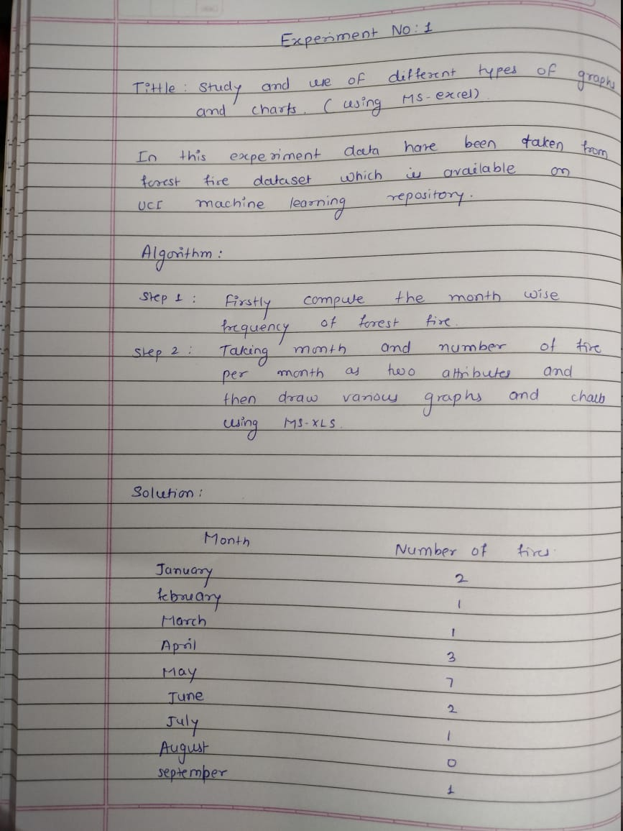

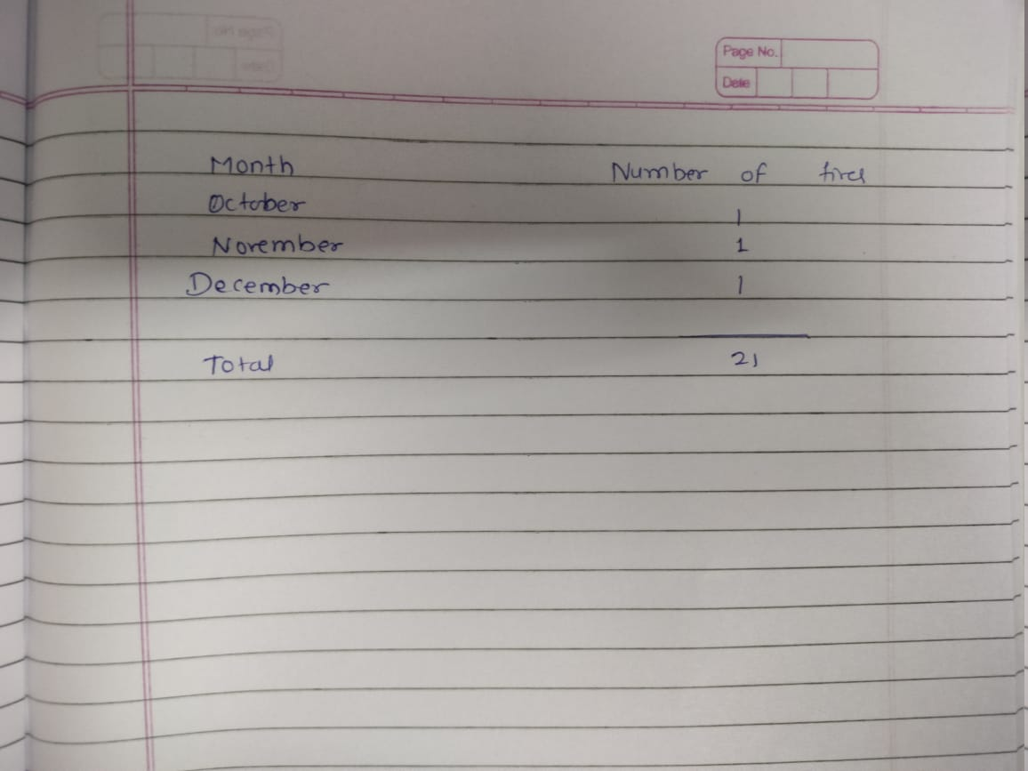

**Forest Fire :**

| **X** | **Y** | **month** | **day** | **FFMC** | **DMC** | **DC** | **ISI** |
| --- | --- | --- | --- | --- | --- | --- | --- |
| 2 | 2 | January | sun | 89.3 | 51.3 | 102.2 | 9.6 |
| 8 | 6 | January | mon | 92.3 | 88.9 | 495.6 | 8.5 |
| 8 | 6 | February | mon | 91.5 | 145.4 | 608.2 | 10.7 |
| 8 | 6 | March | tue | 91 | 129.5 | 692.6 | 7 |
| 7 | 5 | April | sat | 92.5 | 88 | 698.6 | 7.1 |
| 7 | 5 | April | sat | 92.5 | 88 | 698.6 | 7.1 |
| 7 | 5 | April | sat | 92.8 | 73.2 | 713 | 22.6 |
| 2 | 2 | May | thu | 93 | 75.3 | 466.6 | 7.7 |
| 6 | 5 | May | fri | 63.5 | 70.8 | 665.3 | 0.8 |
| 6 | 5 | May | mon | 90.9 | 126.5 | 686.5 | 7 |
| 6 | 5 | May | wed | 92.9 | 133.3 | 699.6 | 9.2 |
| 6 | 5 | May | fri | 93.3 | 141.2 | 713.9 | 13.9 |
| 5 | 5 | May | sat | 91.7 | 35.8 | 80.8 | 7.8 |
| 8 | 5 | May | mon | 84.9 | 32.8 | 664.2 | 3 |
| 6 | 4 | June | wed | 89.2 | 27.9 | 70.8 | 6.3 |
| 6 | 4 | June | sat | 86.3 | 27.4 | 97.1 | 5.1 |
| 6 | 4 | July | tue | 91 | 129.5 | 692.6 | 7 |
| 7 | 4 | September | sun | 94.3 | 96.3 | 200 | 56.1 |
| 7 | 4 | October | sat | 90.2 | 110.9 | 537.4 | 6.2 |
| 7 | 4 | November | sat | 93.5 | 139.4 | 594.2 | 20.3 |
| 2 | 2 | December | fri | 86.6 | 13.2 | 43 | 5.3 |

**Line chart**

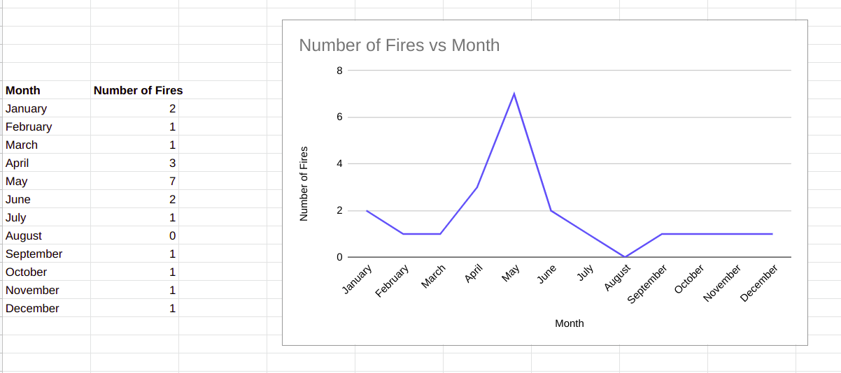

**Combo chart**

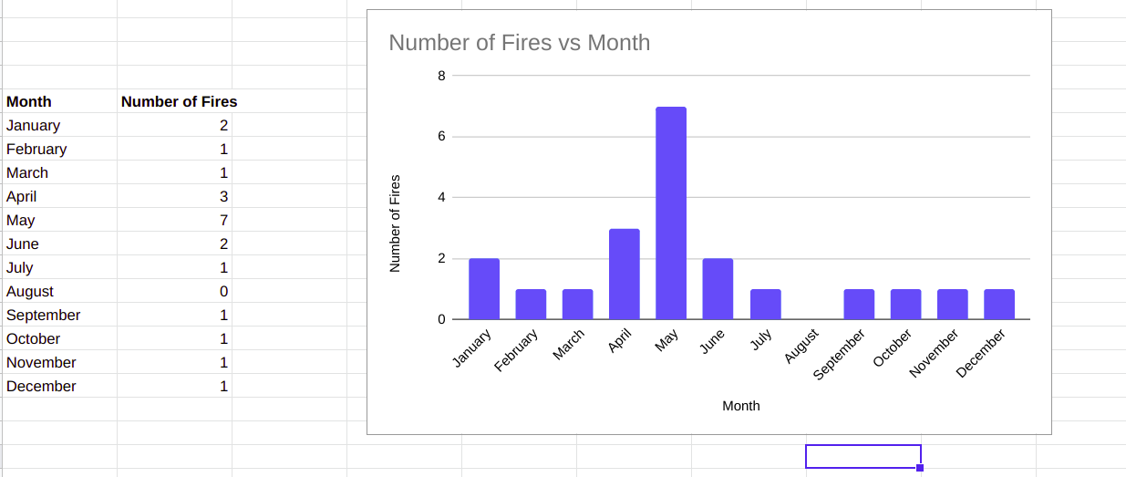

**3d pie chart**

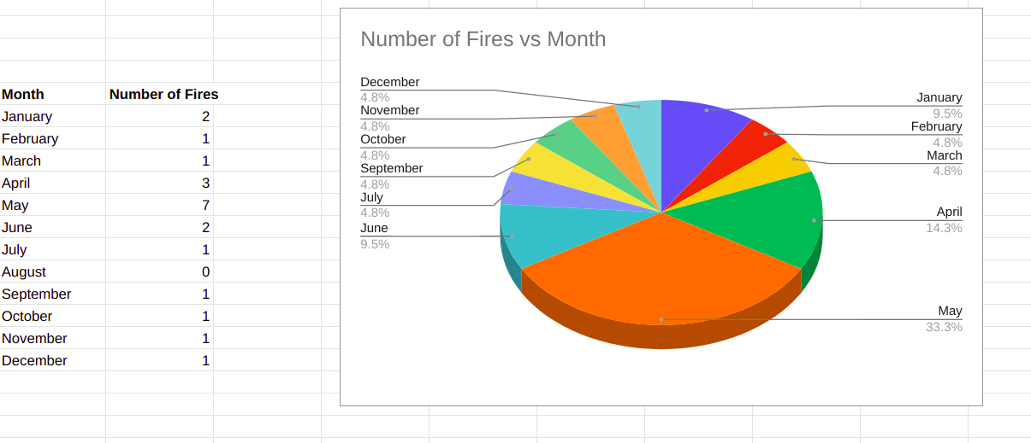

**Scatter chart**

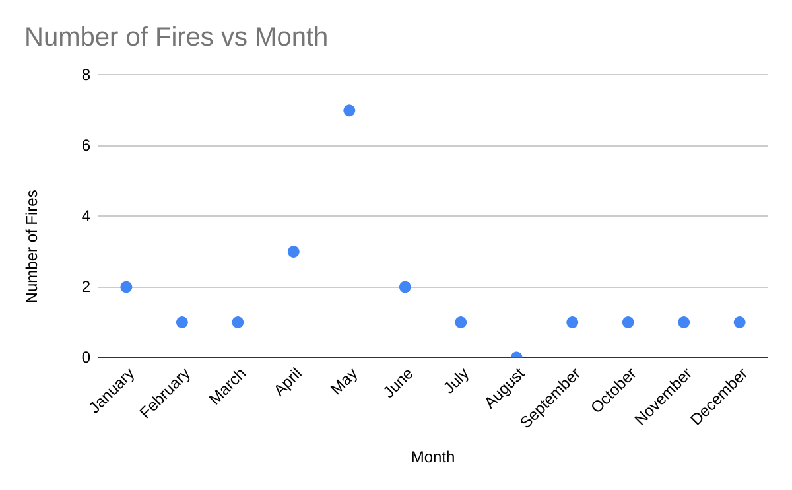

**Conclusion :**

In this experiment , I have taken a data set for forest fire which is available on UCI machine learning repository which helps me to draw and study various graphs for a huge data set.

**Experiment 2**

Perform Normalization of data (Min-max and Z-score)

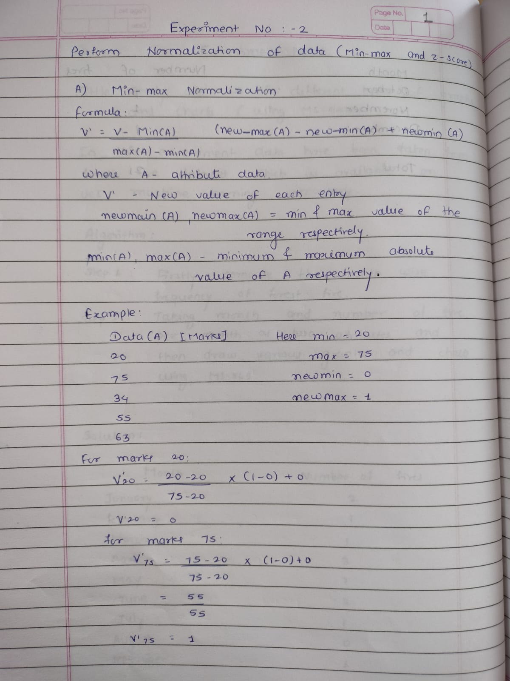

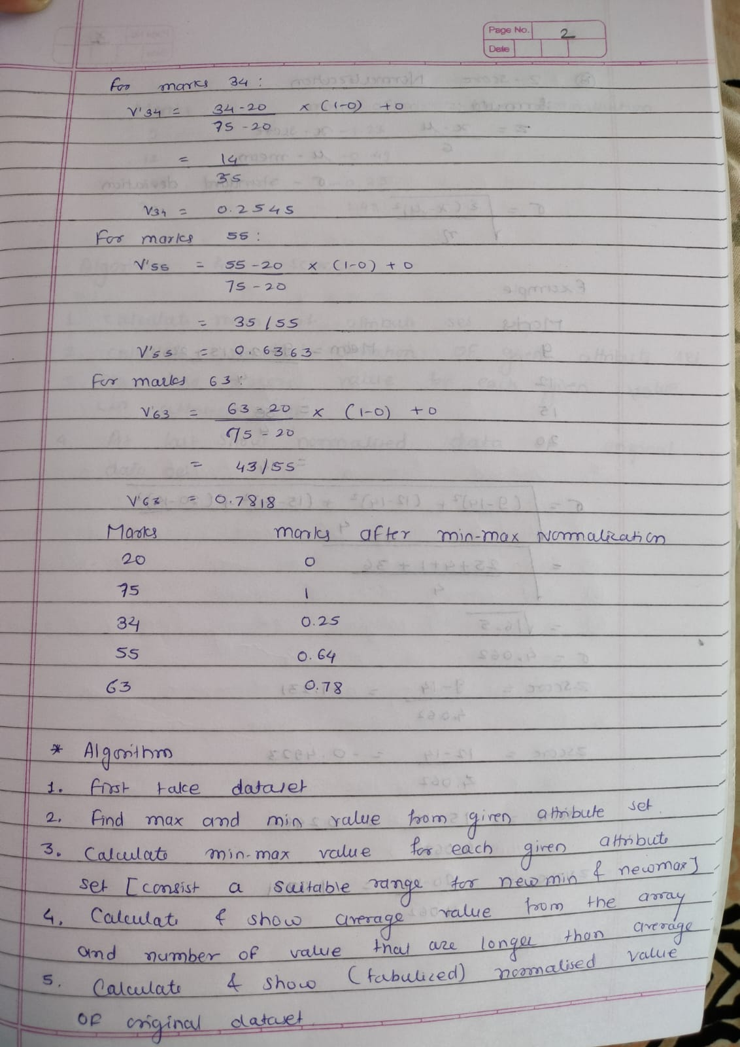

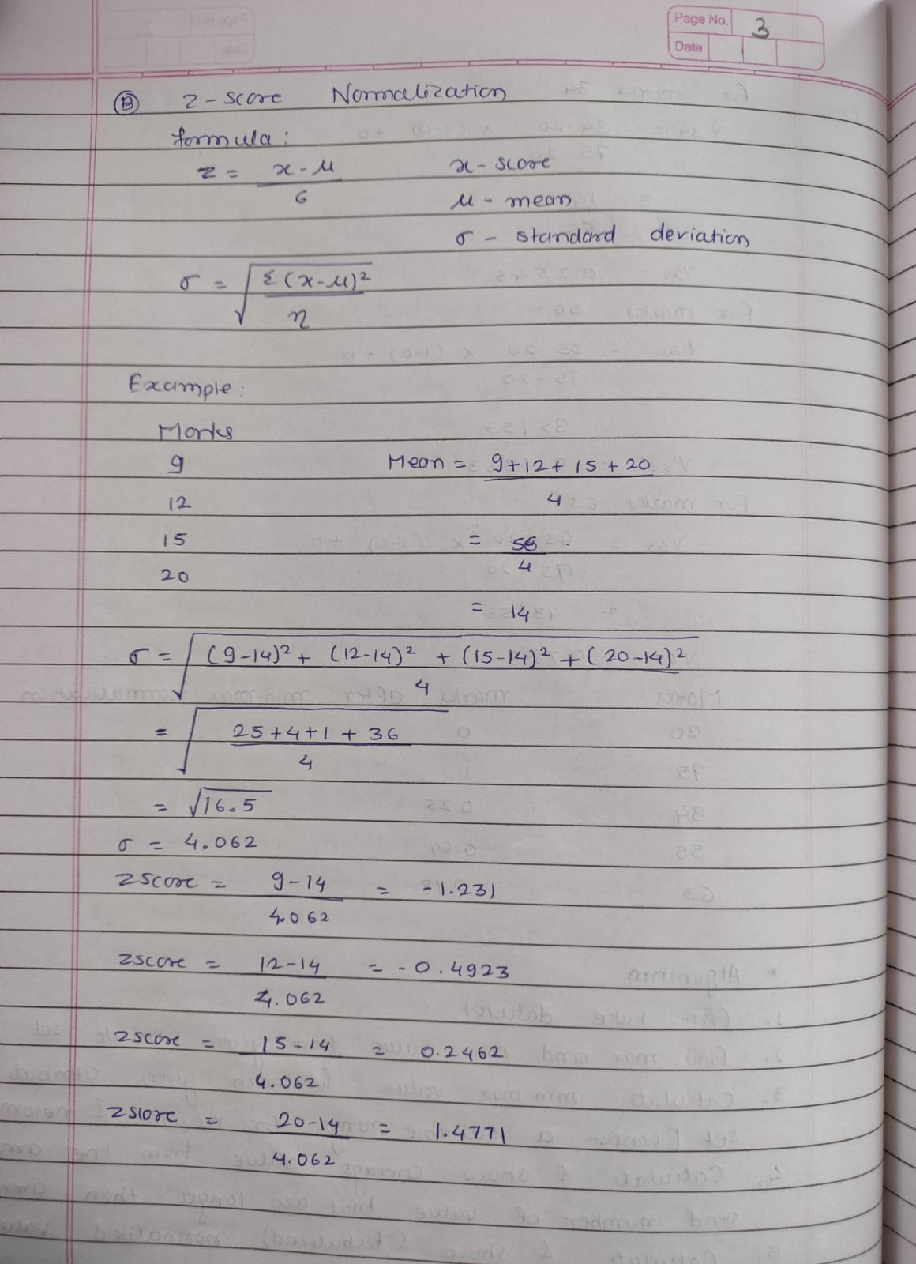

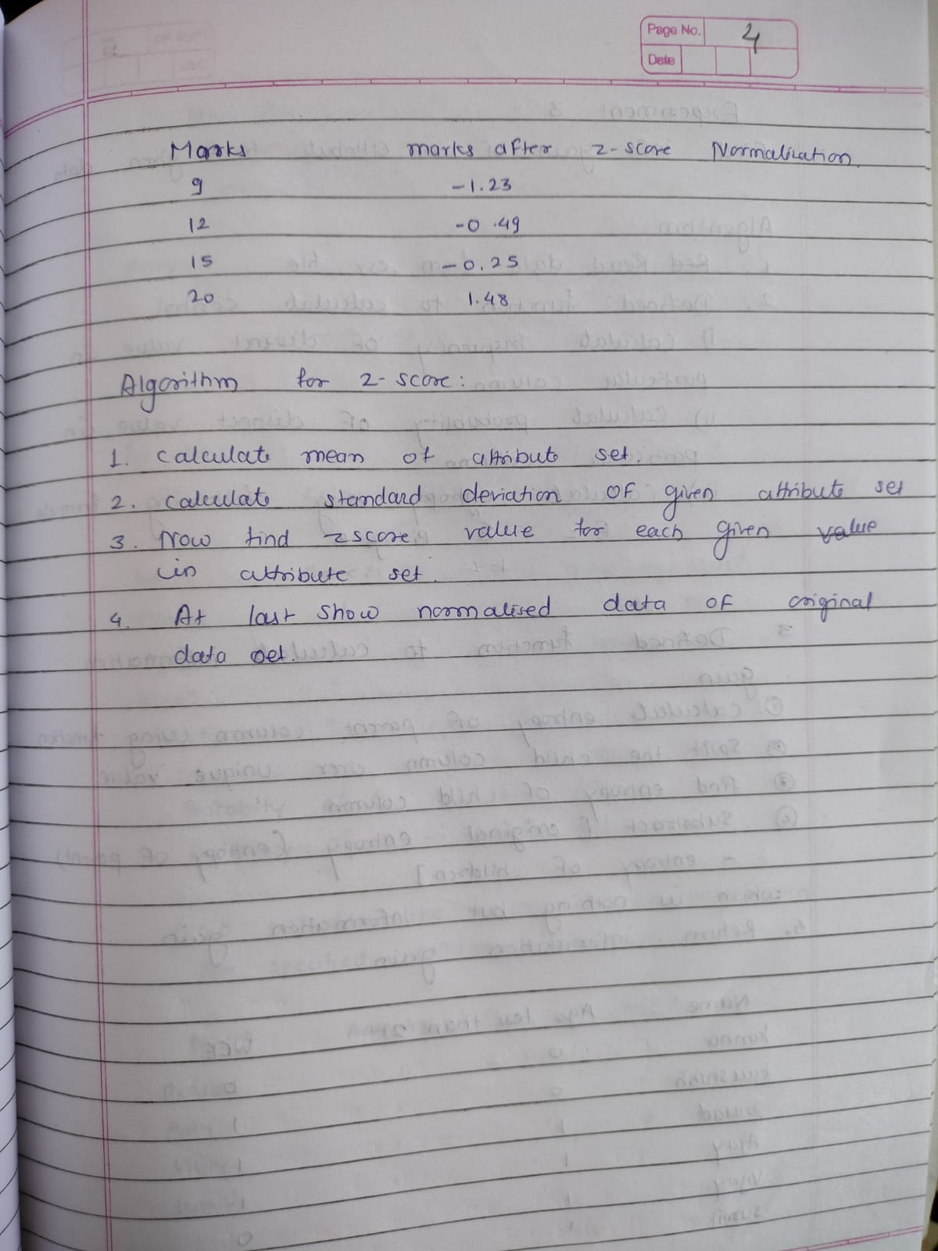

Language used: Python

Libraries and package used: openpyxl , numpy

**Code :**

**_________________________**

**#include <bits/stdc++.h>**

**#include <iostream>**

**#include <fstream>**

**#include <string>**

**#include <vector>**

**#include <sstream>**

**#include <ostream>**

**using namespace std;**

**int main()**

**{**

**fstream file("/home/palak/Documents/assignments/dm/datafile/new_norm.csv", ios::in);**

**if (!file.is_open())**

**{**

**perror("Error : ");**

**return 0;**

**}**

**string line, mark;**

**vector<double> marks;**

**int i = 0;**

**while (getline(file, line))**

**{**

**if (i == 0)**

**{**

**i++;**

**continue;**

**}**

**stringstream str(line);**

**getline(str, mark, ',');**

**double mk = stod(mark);**

**marks.push_back(mk);**

**}**

**int n = marks.size();**

**sort(marks.begin(), marks.end());**

**double old_min = marks[0];**

**double old_max = marks[n - 1];**

**double new_min, new_max;**

**cout << "Enter New Minimum :";**

**cin >> new_min;**

**cout << "Enter New Maximum :";**

**cin >> new_max;**

**ofstream fout("/home/palak/Documents/assignments/dm/datafile/minmax_op.csv", ios::app);**

**if (!fout.is_open())**

**{**

**cout << "Error in creating min_max normalised file";**

**return -1;**

**}**

**fout << "Marks"**

**<< ","**

**<< "Min_Max_normalised Marks" << endl;**

**for (auto x : marks)**

**{**

**double normalised_marks = (((x - old_min) / (old_max - old_min)) * (new_max - new_min)) + new_min;**

**fout << x << "," << normalised_marks << endl;**

**}**

**fout.close();**

**file.close();**

**double sum = 0;**

**for (auto mk : marks)**

**{**

**sum += mk;**

**}**

**double dev_sq = 0;**

**double mean = sum / n;**

**for (auto mk : marks)**

**{**

**dev_sq += (mk - mean) * (mk - mean);**

**}**

**double std_dev = sqrt(dev_sq / n);**

**ofstream fw2("/home/palak/Documents/assignments/dm/datafile/zscore.csv", ios::app);**

**if (!fw2.is_open())**

**{**

**cout << "Error in Opening z-score data file";**

**return -1;**

**}**

**fout << "Marks"**

**<< ","**

**<< "Z-score Marks";**

**for (auto mk : marks)**

**{**

**double z_score = (mk - mean) / std_dev;**

**fw2 << mk << "," << z_score << endl;**

**}**

**fw2.close();**

**return 0;**

**}**

**Input file :**

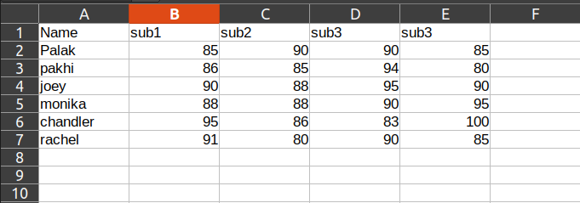

| **Table :**  Name |  | sub1 | sub2 | sub3 | sub3 |  |
| --- | --- | --- | --- | --- | --- | --- |
| Palak |  | 85 | 90 | 90 | 85 |  |
| pakhi |  | 86 | 85 | 94 | 80 |  |
| joey |  | 90 | 88 | 95 | 90 |  |
| monika |  | 88 | 88 | 90 | 95 |  |
| chandler |  | 95 | 86 | 83 | 100 |  |
| rachel |  | 91 | 80 | 90 | 85 |  |
|  |  |  |  |  |  |  |

**Output file :**

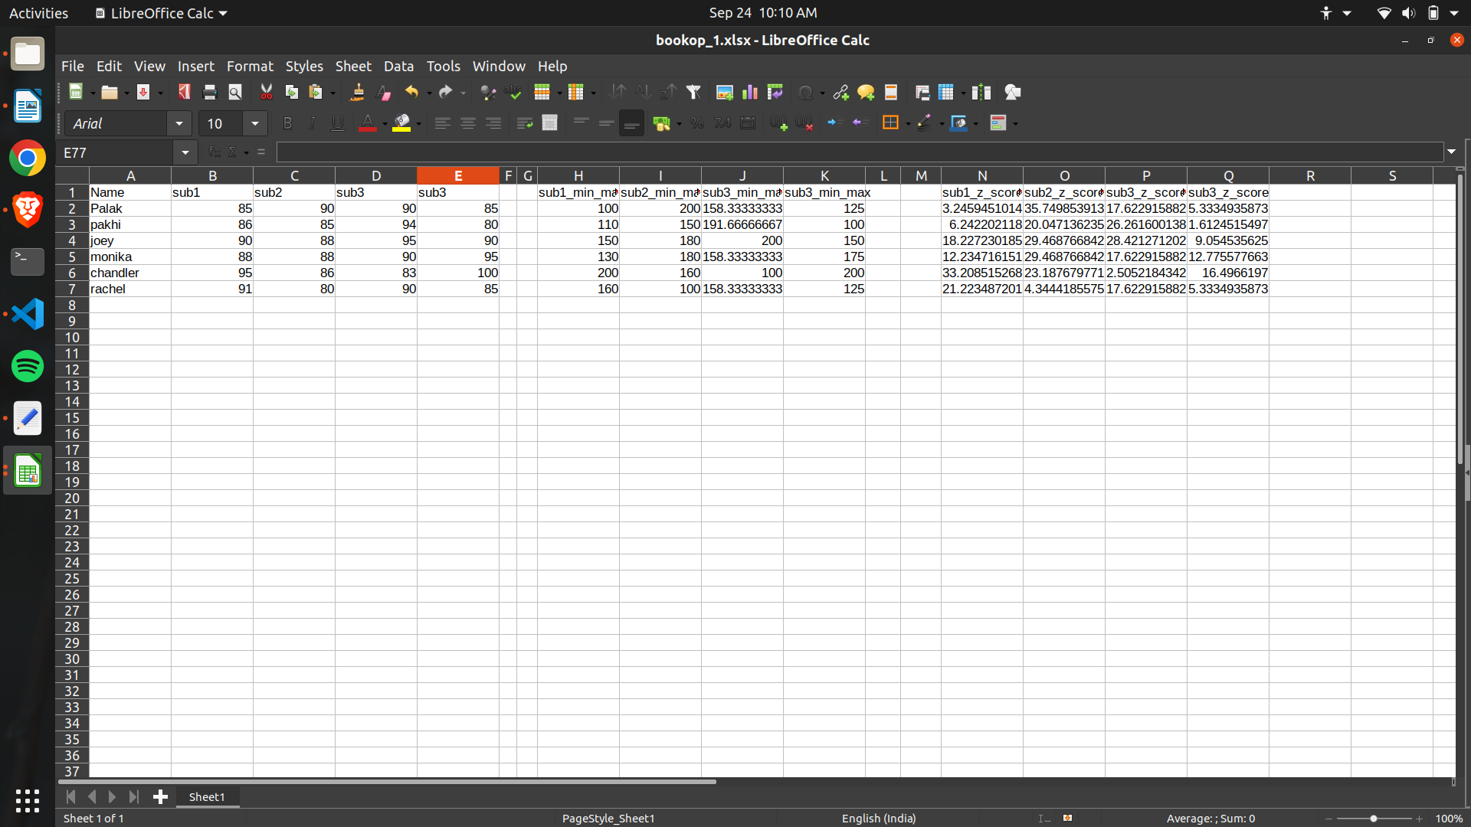

**Experiment 3**

Find Info Gain of an attribute from given data.

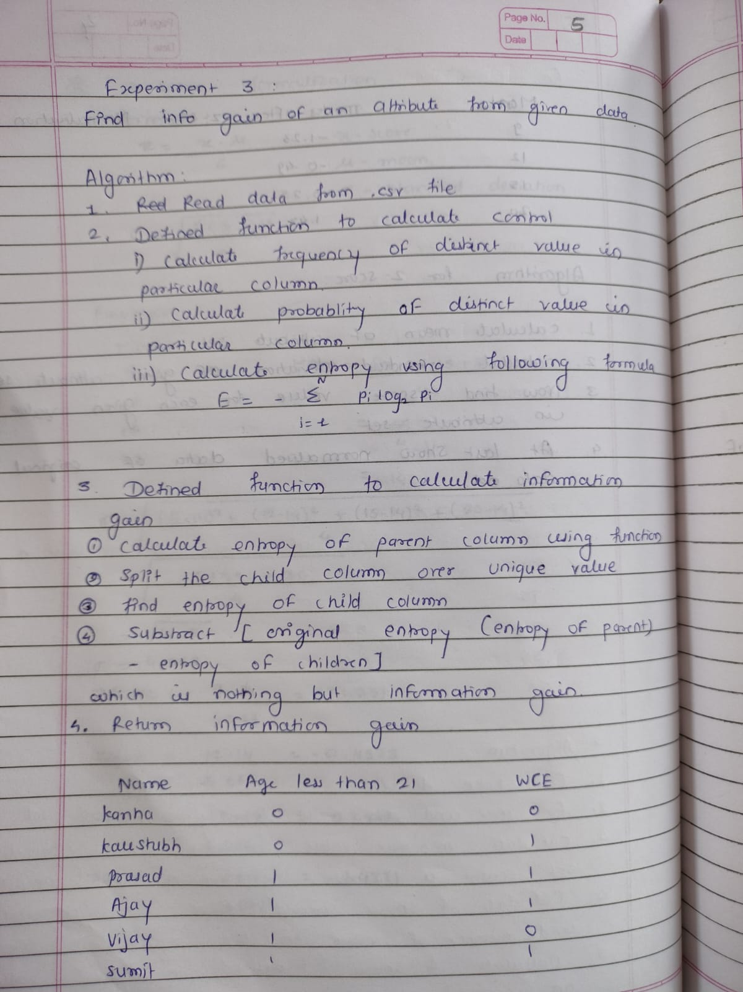

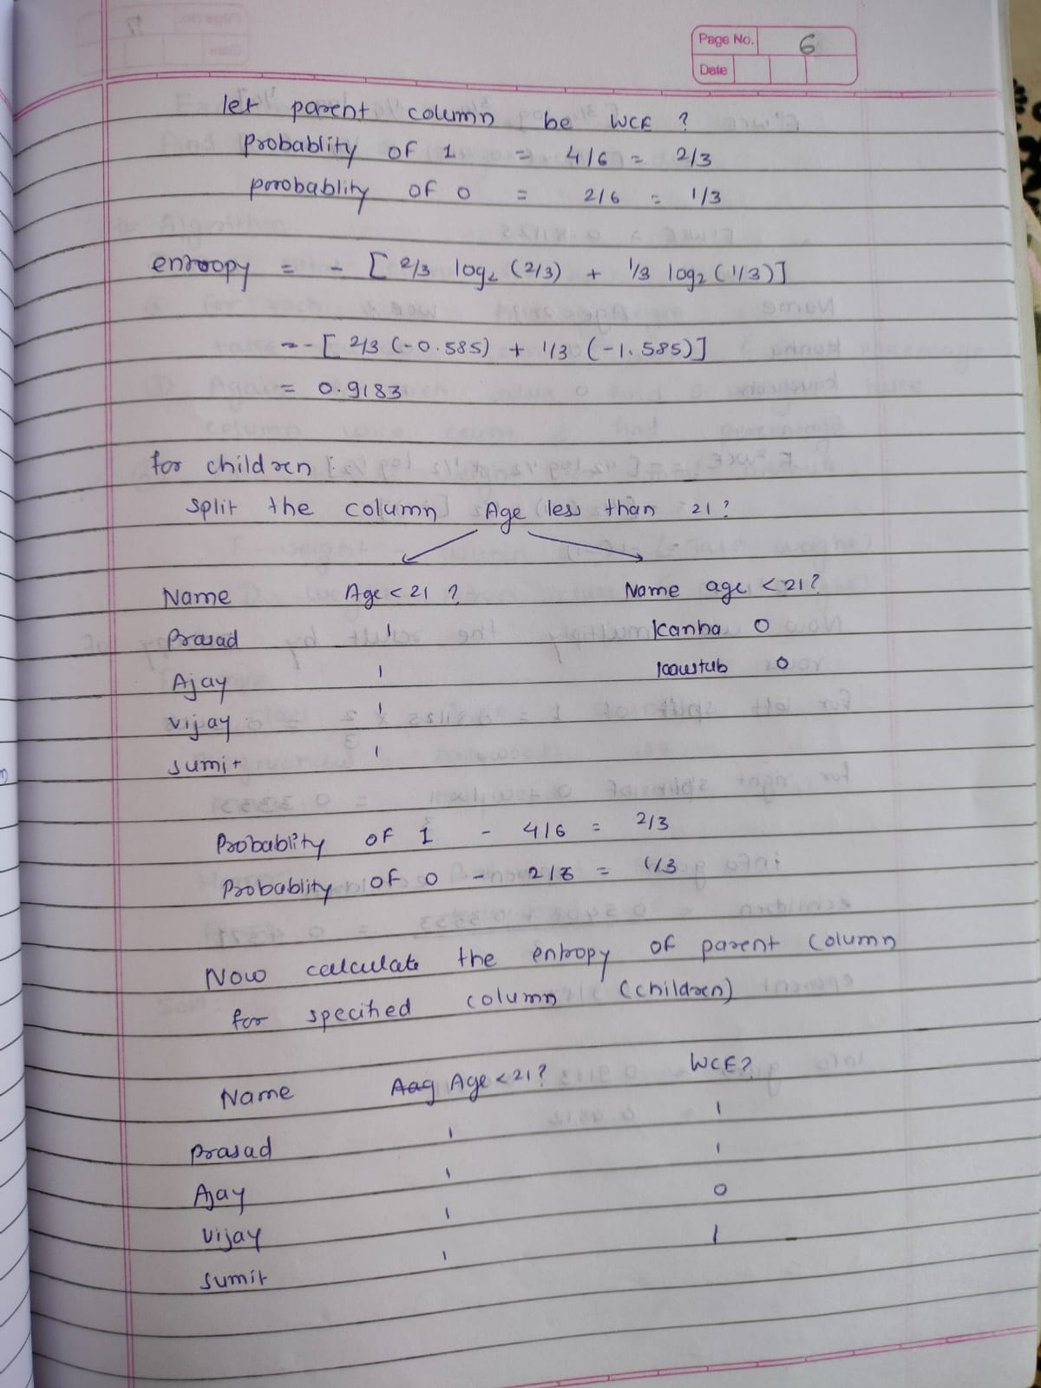

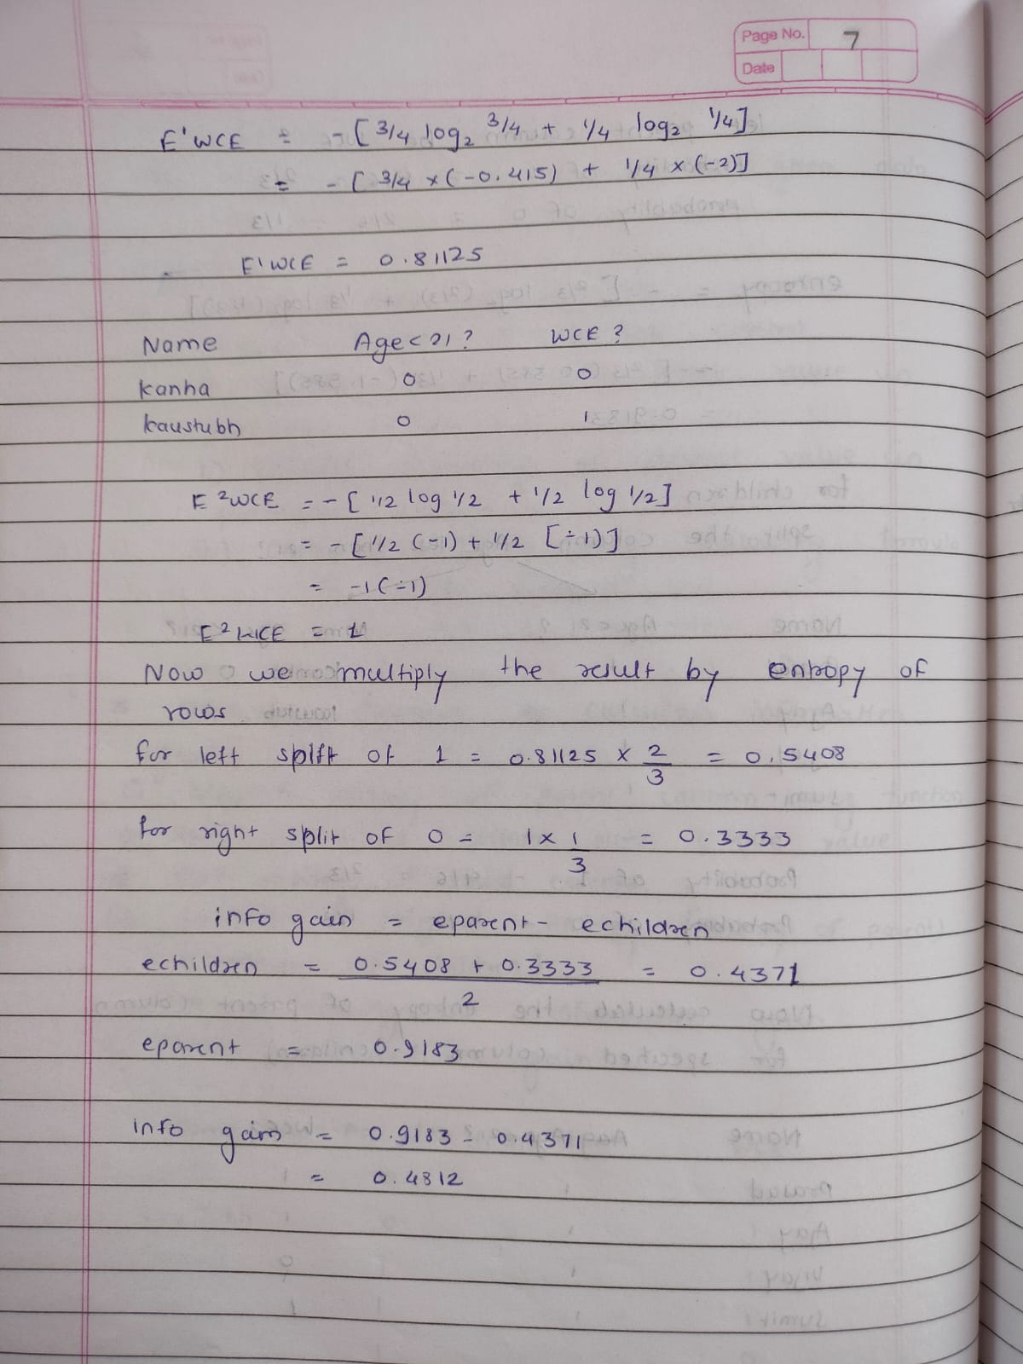

**Code :**

**________________________________________________________________________________________________________**

**from csv import writer**

**import pandas as pd**

**import numpy as np**

**import math**

**file = pd.read_csv(**

**"/home/palak/Documents/assignments/dm/datafile/infogain_ip.csv")**

**def calc_entropy(column):**

**"""**

**Calculate entropy given a pandas series, list, or numpy array.**

**"""**

**l = column.shape[0]**

**freq = {}**

**for item in column:**

**if (item in freq):**

**freq[item] += 1**

**else:**

**freq[item] = 1**

**probabilities = {}**

**for item in column:**

**probabilities[item] = freq[item]/l**

**# Initialize the entropy to 0**

**entropy = 0**

**# Loop through the probabilities, and add each one to the total entropy**

**for prob in probabilities:**

**if probabilities[prob] > 0:**

**# use log from math and set base to 2**

**entropy += probabilities[prob] * math.log(probabilities[prob], 2)**

**return -entropy**

**def calc_information_gain(data, split_name, target_name):**

**"""**

**Calculate information gain given a data set, column to split on, and target**

**"""**

**# Calculate the original entropy**

**original_entropy = calc_entropy(data[target_name])**

**# Find the unique values in the column**

**values = data[split_name].unique()**

**# Make two subsets of the data, based on the unique values**

**left_split = data[data[split_name] == values[0]]**

**right_split = data[data[split_name] == values[1]]**

**# Loop through the splits and calculate the subset entropies**

**to_subtract = 0**

**for subset in [left_split, right_split]:**

**prob = (subset.shape[0] / data.shape[0])**

**to_subtract += prob * calc_entropy(subset[target_name])**

**# Return information gain**

**print(original_entropy - to_subtract)**

**return original_entropy - to_subtract**

**arr = list(file.columns)**

**length = len(arr)**

**i = 1**

**row_contents = ["Info Gain"]**

**while i < length-1:**

**info_gain = calc_information_gain(file, arr[i], arr[length-1])**

**row_contents.append(info_gain)**

**i = i+1**

**def append_list_as_row(file_name, list_of_elem):**

**with open(file_name, 'a+', newline='') as write_obj:**

**csv_writer = writer(write_obj)**

**csv_writer.writerow(list_of_elem)**

**append_list_as_row(**

**'/home/palak/Documents/assignments/dm/datafile/infogain_ip.csv', row_contents)**

Input File :

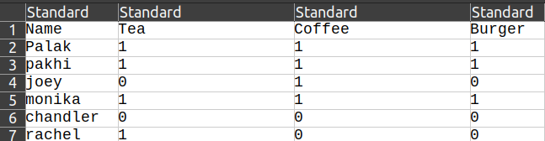

Output file :

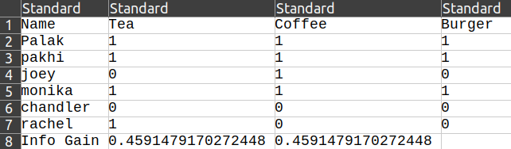

**Experiment 4**

Find t and d weight of a data.

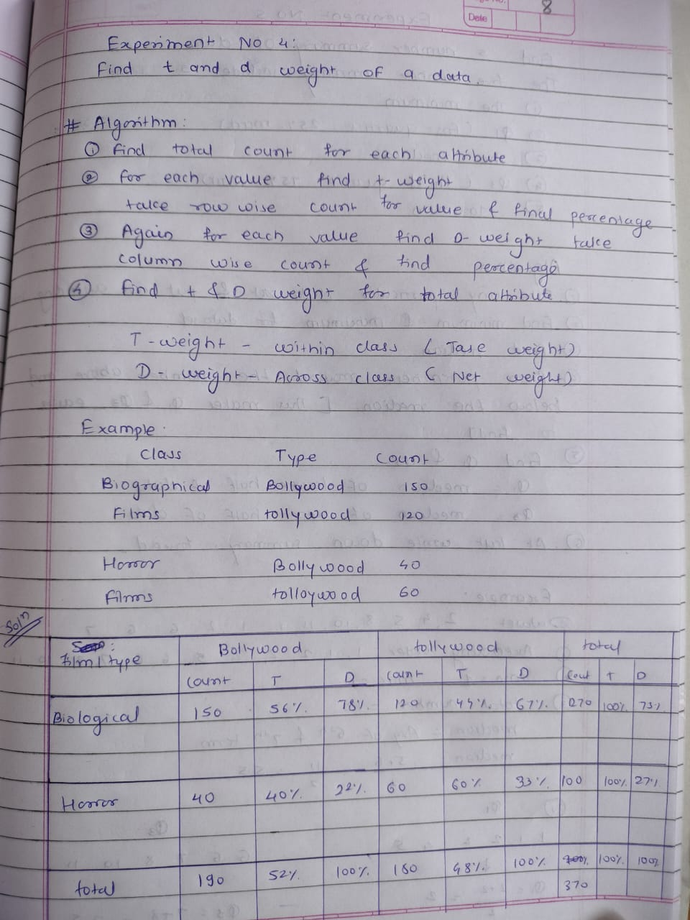

**Code :**

**____________**

**import pandas as pd**

**df = pd.read_csv(**

**'/home/palak/Documents/assignments/dm/datafile/t&d_wt.csv', names=['A', 'B'])**

**data = df.values.tolist()**

**c1_tot = 0**

**c2_tot = 0**

**r1_tot = 0**

**r2_tot = 0**

**for i in range(2):**

**for j in range(2):**

**if (i == 0):**

**r1_tot = r1_tot+int(float(data[i][j]))**

**if (i == 1):**

**r2_tot = r2_tot+int(float(data[i][j]))**

**if (j == 0):**

**c1_tot = c1_tot+int(float(data[i][j]))**

**if (j == 1):**

**c2_tot = c2_tot+int(float(data[i][j]))**

**print("Row 1 Total :", r1_tot)**

**print("Row 2 Total :", r2_tot)**

**print("Col 1 Total :", c1_tot)**

**print("Col 2 Total :", c2_tot)**

**print("")**

**for i in range(2):**

**for j in range(2):**

**if (i == 0):**

**print("t_weight for data " +**

**str(data[i][j]) + " is: ", float((data[i][j]/r1_tot) * 100))**

**if (i == 1):**

**print("t_weight for data " +**

**str(data[i][j]) + " is: ", float((data[i][j]/r2_tot) * 100))**

**if (j == 0):**

**print("d_weight for data " +**

**str(data[i][j]) + " is: ", float((data[i][j]/c1_tot) * 100))**

**if (j == 1):**

**print("d_weight for data " +**

**str(data[i][j]) + " is: ", float((data[i][j]/c2_tot) * 100))**

**Input file:**

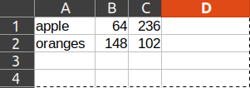

**Output:**

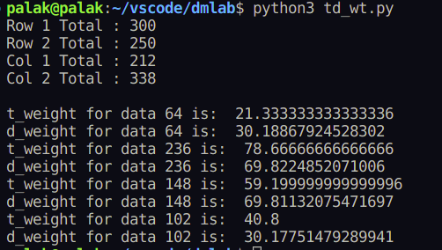

**Experiment 5**

Find 5 no summary of a dataset.

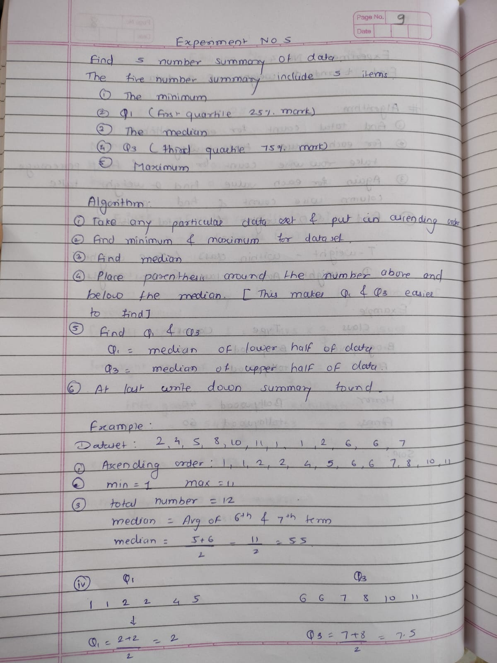

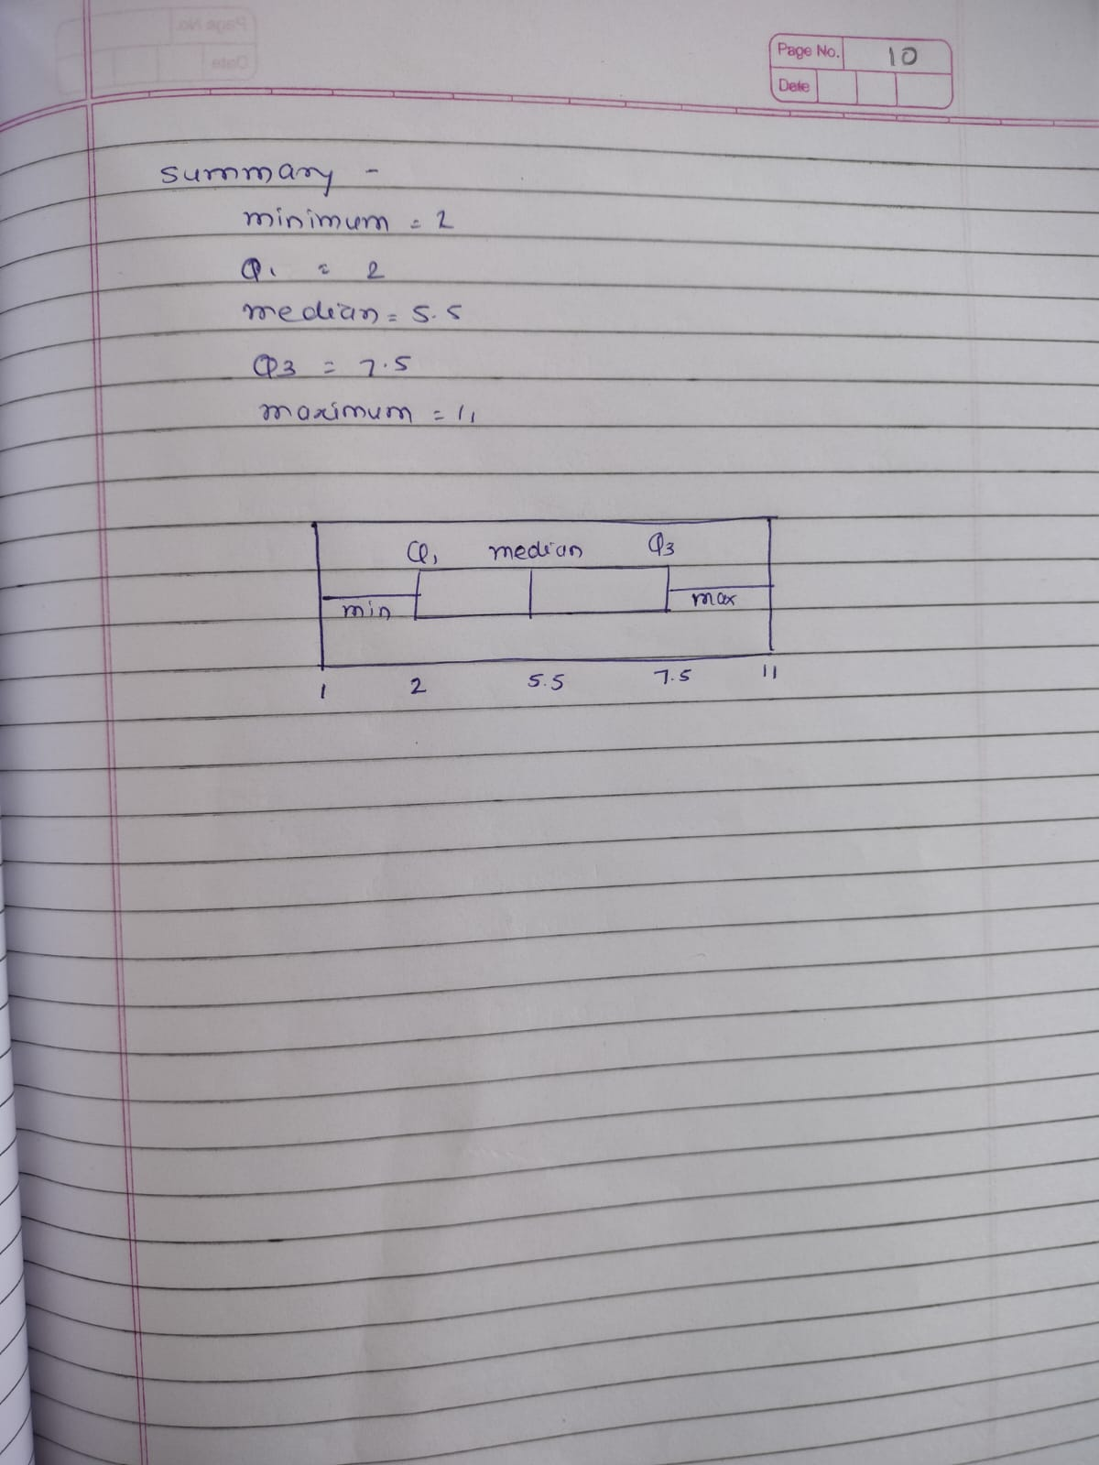

**Code :**

**__________________**

**import openpyxl**

**import math**

**def cal_median(array, l, r):**

**n = r+l**

**median = 0**

**if n % 2 == 0:**

**median = array[n//2]**

**else:**

**median1 = array[n//2]**

**median2 = array[(n//2) + 1]**

**median = (median1 + median2)/2**

**return median**

**def five_no_summary(Arr, Ans):**

**min = Arr[0]**

**max = Arr[0]**

**for x in Arr:**

**if (x < min):**

**min = x**

**for x in Arr:**

**if (x > max):**

**max = x**

**Arr.sort()**

**n = len(Arr)**

**# Median**

**Med = cal_median(Arr, 0, n-1)**

**# Q1,Q3**

**Q1 = 0**

**Q3 = 0**

**if (n % 2 == 0):**

**Q1 = cal_median(Arr, 0, (n//2)-1)**

**Q3 = cal_median(Arr, n//2, n-1)**

**else:**

**Q1 = cal_median(Arr, 0, (n//2)-1)**

**Q3 = cal_median(Arr, (n+1)//2, n-1)**

**Ans.append(min)**

**Ans.append(Q1)**

**Ans.append(Med)**

**Ans.append(Q3)**

**Ans.append(max)**

**wb = openpyxl.load_workbook(**

**"/home/palak/Documents/assignments/dm/datafile/numsum_.xlsx")**

**sheet_obj = wb.active**

**row = sheet_obj.max_row**

**col = sheet_obj.max_column**

**i = 1**

**# for i in range(1,col+1):**

**arr = []**

**ans = []**

**for j in range(2, row+1):**

**val = sheet_obj.cell(row=j, column=i)**

**arr.append(val.value)**

**five_no_summary(arr, ans)**

**i = 0**

**j = 2**

**arr1 = ["Min", "Quatrile1", "Median/Quatrile2", "Quatrile3", "Max"]**

**for i in range(0, 5):**

**c0 = sheet_obj.cell(row=j, column=3)**

**c1 = sheet_obj.cell(row=j, column=4)**

**c0.value = arr1[i]**

**c1.value = ans[i]**

**i = i+1**

**j = j+1**

**wb.save("/home/palak/Documents/assignments/dm/datafile/numsum_.xlsx")**

**Input file :**

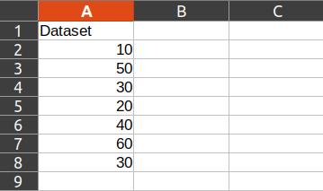

**Output file :**

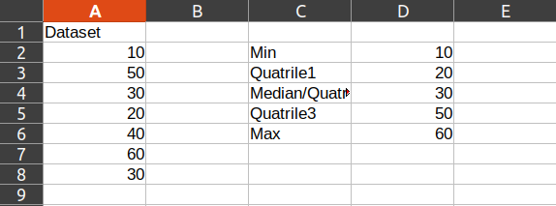

**Experiment 6**

Find frequent itemset from given transaction data

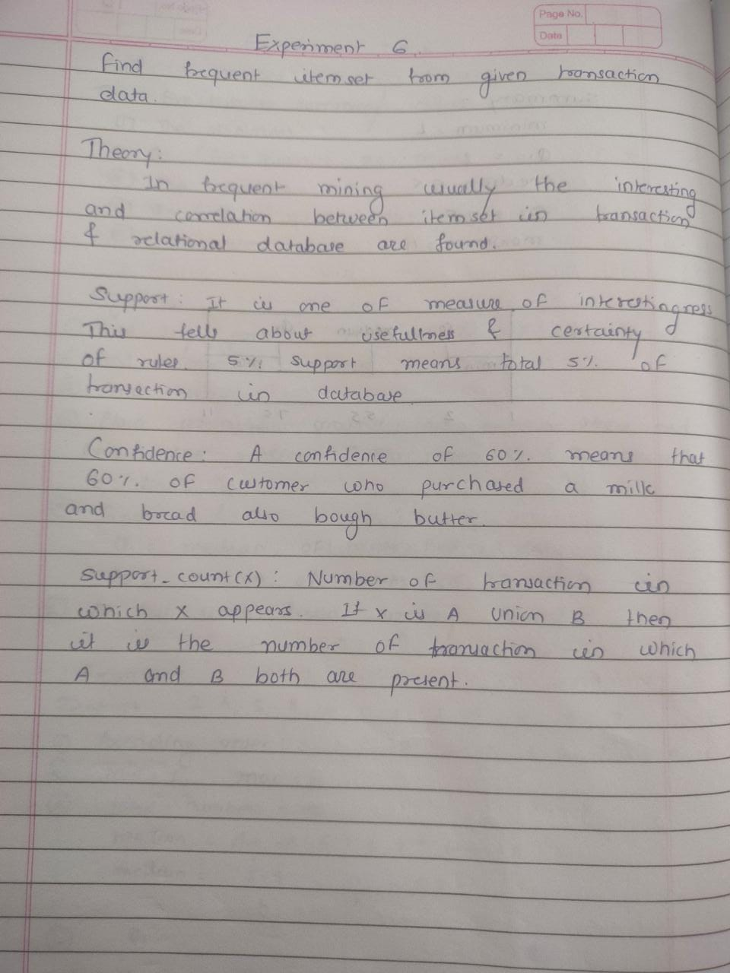

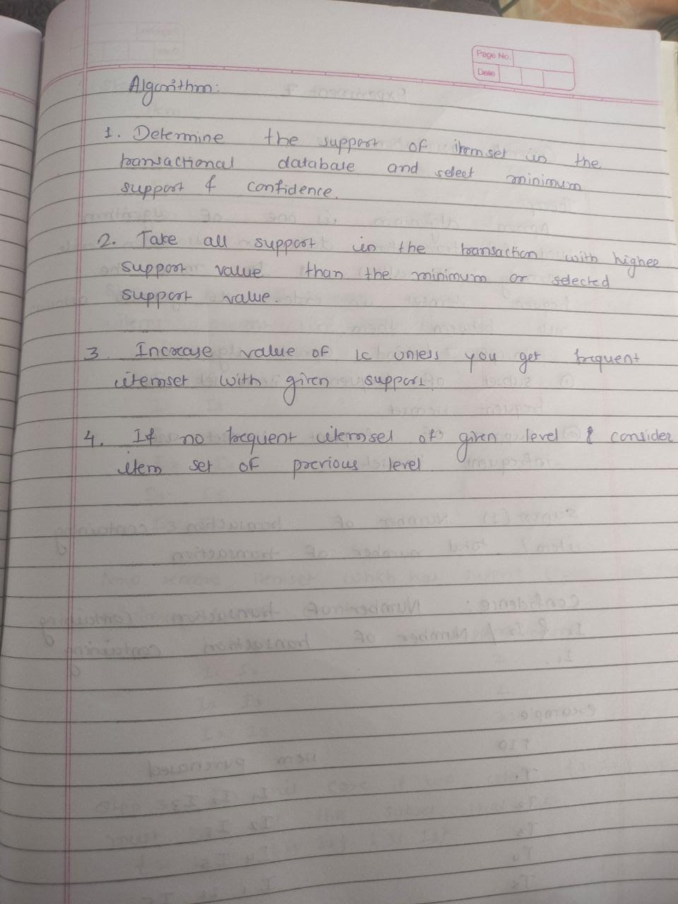

**Code :**

**____________**

**import math**

**from itertools import combinations**

**def read_data_in_dict(filename):**

**f = open(filename)**

**lines = f.readlines()**

**transactions = []**

**items = lines[0].split(',')**

**for line in lines[1:]:**

**transactions.append(list(map(int, line.split(','))))**

**data = {**

**'items': items,**

**'transactions': transactions**

**}**

**return data**

**data = read_data_in_dict(**

**'/home/palak/Documents/assignments/dm/datafile/freqitem.csv')**

**def get_freq(s, items, transactions):**

**freq = 0**

**for t in transactions:**

**temp = 1**

**for item in s:**

**temp *= t[items.index(item)]**

**if temp == 1:**

**freq += 1**

**return freq**

**def frequent_itemsets(data, level, min_support):**

**items = data['items']**

**transactions = data['transactions']**

**min_freq = math.ceil(min_support*len(transactions))**

**sets = list(combinations(items, level))**

**frequent_sets = []**

**for s in sets:**

**freq = get_freq(s, items, transactions)**

**if freq >= min_freq:**

**frequent_sets.append(s)**

**print(frequent_sets)**

**return frequent_sets**

**frequent_itemsets(data, 2, 0.5)**

Input file :

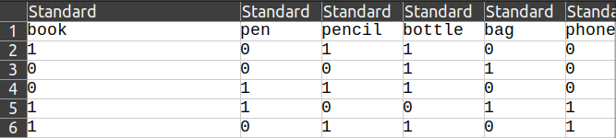

Output :

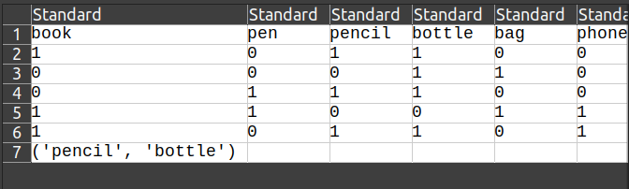

**Experiment 6**

Extend program 6, to find association rules .

